LED Scoreboard
PGA TOUR, Champions & Korn Ferry Tour

Tournament Instructions and Graphical Style Guide
(Revised 11/28/2023)

Section 1: Introduction

Given the consistency with which TOUR LED Scoreboards are placed in Unavoidable Television Camera Range (UTCR), the following guidelines must be followed when submitting any local tournament graphics (LTGs) for use on TOUR LED Scoreboards:
- Secondary sponsor or partner logos can only be utilized on LTGs during non-competition days and must adhere to the parameters outlined within this document
- On competition days, secondary or partner names may appear in text on LTGs so long as the message within the LTG is deemed to be a fan benefit or enhancement
- Messaging during competition days should not be used as a commercial entity with sponsors or partners
- All LTGs must be submitted for TOUR approval via TB Operations & Fan Engagement team prior to advance week

It is recommended that tournaments appoint a staff member or volunteer with graphics experience to be the graphics chairperson (the point person to work on the graphics).

Section 2. Resources & Style Guide

The PGA TOUR will supply a Photoshop template (.psd file) for creation of local tournament graphics to be submitted as PNG (.png) or JPEG (.jpg) files. A thirty-day trial of Photoshop CS or Elements can be downloaded from Adobe.com. Elements can be purchased for less than one hundred dollars. There are also free graphics applications available on the Web, such as GIMP.

The tournament logo must be in the left 30% of every slide and sponsor recognition & local messaging must be on the right side. Using text only is preferable for all LTGs with local messaging and acknowledge of secondary tournament sponsors. However, for non-competition days, should secondary sponsor logos be used, logos must be accompanied with a designation (i.e., “Official Sponsor of…”, “Special Thanks To”, etc.). When recognizing a distilled spirit sponsor, the type of alcohol must not be used. Additionally, logos of distilled spirits companies must not include the type of spirit.

Websites, URLs, Phone numbers or domain names may not be put on any slides unless the Title Sponsor is a website, such as Frys.com. When referencing a tournament page on Facebook, the messaging can read: “Find us on Facebook.” It cannot read:
“Facebook.com/tournament.”

Tournaments can submit slides that display tournament staff names, tournament sponsors, pro-am and clinic information, and other tournament messaging that is deemed to enhance or promote the fan experience. Tournaments are responsible for the accuracy of spelling, dates, and times. If changes need to be made, new files must be re-submitted. The onsite staff cannot make these changes.

The TOUR will continue to create the full-screen tournament logo slide, so there is no need for the tournament graphics chairperson to create one.

Section 3a: Examples from Tournaments (Non-Competition Days)

Additionally, logos of distilled spirits companies must not include the type of spirit. See below for examples.

Section 4: Technical Specifications and Submission Guidelines

The Tour has four sizes of LED scoreboards.

- 624x312 – Modular Korn Ferry Tour only
- 608x228 – Large TOUR board

- 512x192 – Medium TOUR board

It is recommended that tournaments maintain their PSD file so that they can easily archive and update the slides as needed in the future.

Once the files are submitted, they will go through an approval process. If LTGs do not adhere to these guidelines, it is possible that some of the files may need to be modified by the tournament and re-submitted. In order to allow enough time for this process, please submit the files prior to advance week.

Once you are ready to make the files, change the image size to make the size you have onsite. It will either be 624x312, 608x228, and/or 512x192.

When saving the files, make sure to create PNG or JPEG files. The .png or .jpg extension must be preceded by a three-digit number, Tournament Name, and text to designate

the order in which the files are to show on the scoreboards and to help easily identify what the files are without having to open them. It is up to the tournament to order them how they want them to show. If a file needs to run up to a specific day such as a Tuesday clinic or a Wednesday pro-am, then the file should be named accordingly. Below is an example of how to name the files:

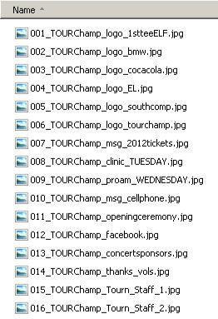

Once the PNG or JPEG slides are created, they need to be zipped up and emailed for approval. On the Champions Tour and Korn Ferry Tour, the files will need to be sent to your TBA representative. On the PGA TOUR, the files will need to be sent to your PGA TOUR Tournament Standards representative. Once approved, your representative will forward your files to the PGA TOUR Data Center for loading on the servers.
Section 5: How to use the template in Photoshop

Smooth, round, or bold fonts are recommended. Some examples are Univers, Arial, and Lucida. Italic fonts should not be used. Fonts should be no smaller than 14 pt. Text in all caps usually looks better but is not required.

Tournaments may change the color of the background; however, we strongly recommend dark backgrounds as they look best. Tournaments can also use a custom background and/or free-form create their slides.

Remember that the tournament logo must be in the left 30% of every slide and Web sites, URLs, or domain names may not be put on any slides!

The best way to allow easy exporting and fixes (e.g. logo updates, spelling errors, date changes, or color changes) is to add a new layer for each additional element used to create the slide, and then save the template rather than renaming a single layer multiple times. That way, one template can be used to create all the tournament slides and the “eye” can be used to make elements visible or not visible as needed when saving the output files. In the two example images below, the single template contains all the layers that have been created for multiple output files.

In the next couple pages, samples will show how to get the desired messaging. Using the “eye” icon, layers will appear and disappear.

Once you have a selection of layers that you like, do a file save as and change the extension to .png of .jpg and name it as specified in the sections above. Make sure to duplicate layers to make more of the same item so you can go back and make edits. Don’t just edit the existing ones or you won’t have any backups. Also, save your PSD file so you don’t lose your work.

If you do not have the Univers font shown in the following examples on your computer, it is attached in the zip file. Just copy it to your C:\windows\fonts directory or your /Users/Your_Username_Here/Library/Fonts directory on your Mac.

Once you are ready to make the files. Change the image size to make the size you have on site. It will either be 624x312, 608x228, and/or 512x192.

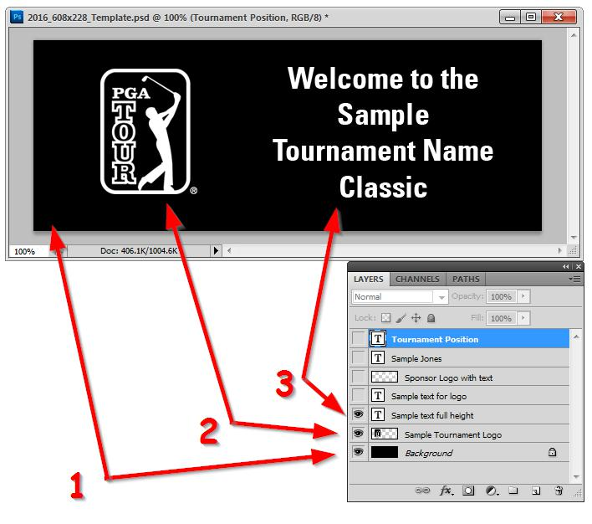

In the first sample above. #1 is the background. #2 is the tournament logo placement. #3 is the messaging that takes up the whole right side. For this example, you can replace the TOUR logo with your tournament logo. The text can be changed to match any wording you need.

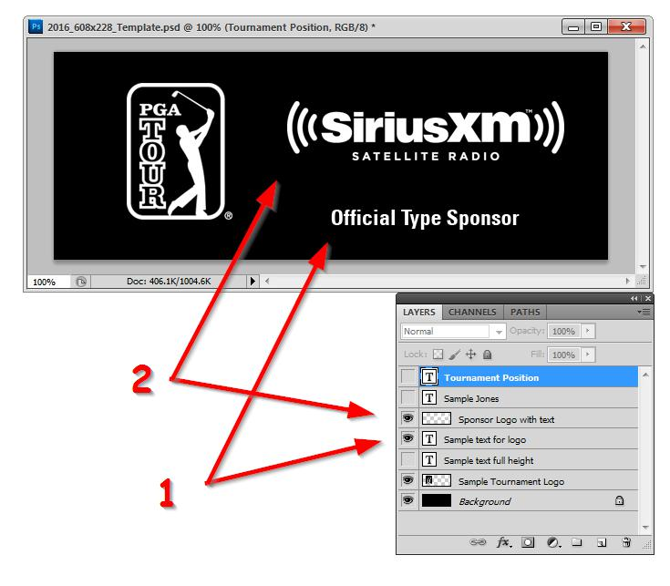

In the second sample above. #1 is the supporting text. #2 is the sponsor logo placement. For this example, you can replace the sponsor logo with any of your sponsor logos and the text can be changed to match any wording you need.

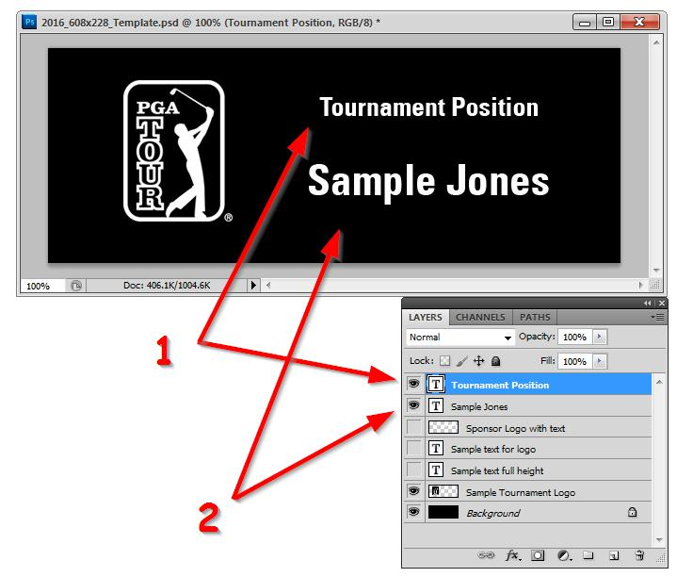

In the third sample above. #1 is the position title. #2 is the person’s name. Since you will most likely be giving credit to multiple people, just duplicate the layer and edit the new layer. This way, you can go back and make changes in the future.

Once you are ready to make the files. Change the image size to make the size you have on site. It will either be 624x312, 608x228, and/or 512x192. Then save the file as directed in the previous sections. Make sure not to save the PSD template in the smaller sizes. You can always use the history tool to undo any action.

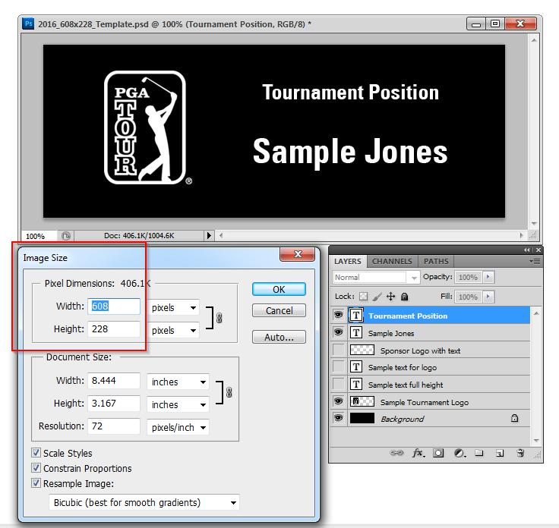

As a reminder, once the PNG or JPEG slides are created, they need to be zipped up and emailed for approval. On the Champions Tour and Korn Ferry Tour, the files will need to be sent to your TBA representative. On the PGA TOUR, the files will need to be sent to your PGA TOUR Tournament Standards representative. Once approved, your representative will forward your files to the PGA TOUR Data Center for loading on the servers.

